2020 Summer
Younger Vibes
Registration Packet

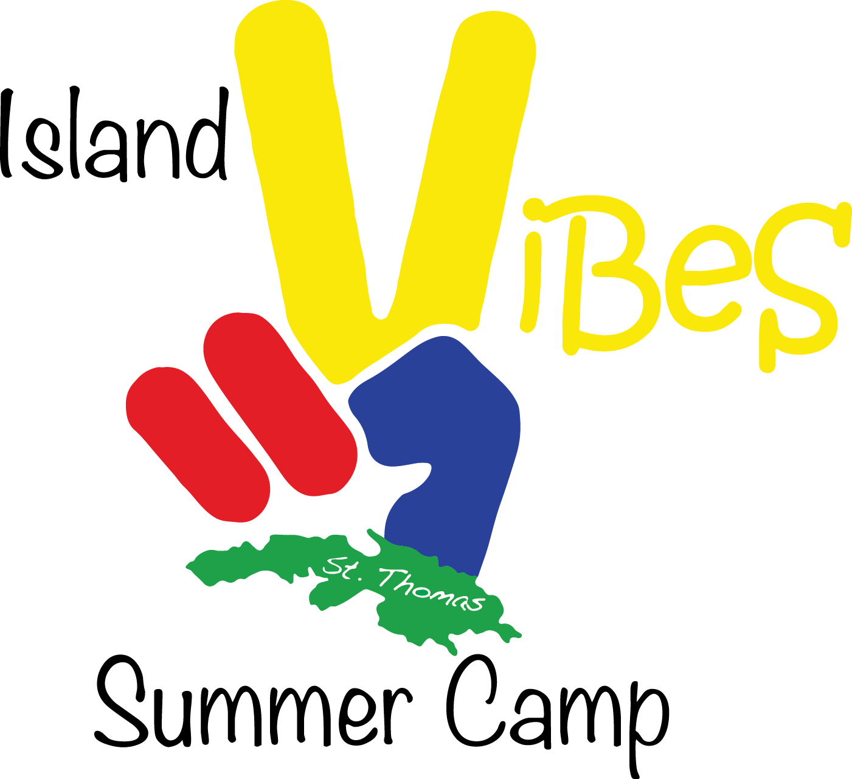

Improve Skills. Explore New Cultures. Discover Paradise!

Please consider the environment before printing.
Packet Contents

- Introduction ………………………………………….3

- About Island Vibes …………………………………..3

- Mission Statement
- Campers

- Camp Sports & Activities ………………………..…..3

- Location ……………..……………………………….4

- Tuition & Fees ……………………………………….5

- FAQ’s (Frequently Asked Questions) ………..……5-7

- Summer Camp Forms ……………………………8-16

Introduction

Island Vibes Summer Camp, a 501 (c)(3) non-profit corporation, is the only summer sports and adventure camp of its kind in the U.S. Virgin Islands. Adventure, action, and fun all take place at the University of the Virgin Islands! This 6-week camp offers a unique opportunity for athletic, social and personal development. Campers will engage in sports, take exciting cultural island tours and field trips.

About Island Vibes Summer Camp

IVSC Founder and Camp Director Vernon Araujo was first introduced to camp when he worked as a camp counselor and coach for his father Adalio Araujo, who started a soccer day camp on St. Thomas in 1998. Vernon also had the opportunity to attend overnight summer camps in Florida and New York as a teenager, experiences which irreversibly changed his life both on and off the field. Island Vibes Summer Camp was created to bring a unique summer experience to the U.S. Virgin Islands so that young athletes may have the opportunity to improve their skills and explore new cultures with Paradise as the backdrop. IVSC aims to help each camper achieve their highest level of athletic ability through healthy competition, sportsmanship and incorporating the philosophy of Olympism.

Offering sports and various cultural activities in a Caribbean setting, the camp is an amazing experience every camper will want to write home about! The objectives of the camp are to offer access to a world class coaching staff, emphasize the importance of team work and environmental responsibility, create a larger sports network for Virgin Islands athletes, encourage campers to consider UVI for furthering their education, expose campers to Virgin Islands culture and experiences and create a safe and structured environment for campers to make friends from around the world!

Mission Statement

To provide a positive environment for athletic and personal development through sports, while exposing campers to new cultures, experiences and people.

Summer Campers

Applications will only be accepted for campers who are between the ages of 4 and 10 by May 15, 2020. For example, if you submit an application for your 3 year old child in February but your child’s birthday is in April, they will be eligible for the camp!

Camp Sports & Activities

Every athlete and parent understands how important summer learning and training can be in bridging the gap between last season and next season. Our sports programs are designed to help our campers achieve their personal best! Be sure to fill out the Registration Form. Camp activities will include cultural arts and crafts, team building projects, beach trips, hikes and a community service project. Each week will bring a new and different experience for each camper!

Location

University of the Virgin Islands
St. Thomas Campus

Conveniently located by the airport, Island Vibes overnight campers will be housed in the University’s dorm rooms!

Facilities
The UVI Sports and Fitness Center is UVI's 64,000 sq. ft. facility for athletics and physical education. It has a portable wood floor for the main court and two other tartan full courts running sideways for practice. In addition, the building houses five classrooms and a VIP sky box/public relations area. The Sports and Fitness Center also is designed to contain a fully functional training room. It is the premier athletic facility of its type in the Caribbean.

S&FC is Home to the University of the Virgin Islands Paradise Jam! The Sports and Fitness Center has become home to the University of the Virgin Islands Paradise Jam, an annual NCAA Division I Basketball tournament held in November during the Thanksgiving recess. See the link below for Paradise Jam details.

Amenities
Outdoor tennis courts, indoor and outdoor basketball courts, on-campus golf course, soccer/baseball field, sports & fitness center. There are also washers and dryers by the dorm area. UVI is also located right near Brewer’s Beach and the Reichhold Center for the Arts.

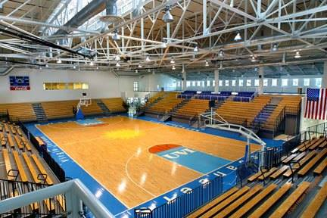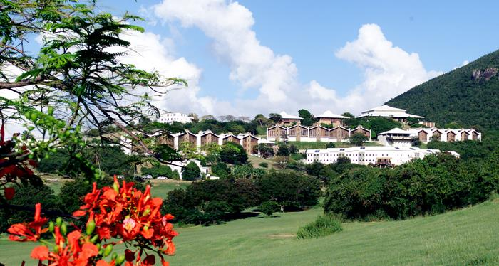

Tuition & Fees

Registration deadline is May 15, 2019. Please see FAQs #12 for more information on camp fees.

Tuition:

DAY CAMPERS
 | Description |  | # of Weeks | Tuition
 | Day Campers will receive camp gear, Olympic level sports training, lunch & snacks. |  | 6 | $200/week

Fees: due upon receipt of registration form

*Registration Fee - $25
*Deposit (to hold space in program) - $50
*Cancellation Insurance - $25

F.A.Q.’S

- When does the camp begin and end?
Our first sessions of camp begins at 9:00AM on June 15, 2020 and ends on June 26, 2020 at 3:30 PM. The second camp session begins on July 27th, 2020 and ends on August 7th, 2020. All forms must be postmarked by May 15, 2020.

2. How old must a child be to attend the camp?
All campers attending a youth sports camp must be between the ages of 4-10 by May 15, 2020. NO exceptions.

- What does a typical camper’s day look like?
Campers will begin each day with fun and engaging exercises and activities! Campers will have lunch on campus and return to their scheduled activities. At the end of the day, campers will be picked up starting at 3:30pm. Please note that every day will be different and more packed with fun than the day before!

- Are campers required to wear camp gear?
No. Although camp apparel will be given to each camper, he/she is only required to wear the Island Vibes t-shirt on field trip days so they are easily identifiable. All campers should bring their personal sports gear such as kneepads, socks, sport specific clothing, etc. There will be a washer and dryer on property.

- What else should campers bring?
  - Hat
  - Back pack
  - Towel
  - Sneakers/tennis shoes
  - Slippers/beach shoes
  - Bathing suit, swim trunks
  - Rain coat, umbrella or poncho
  - Insect repellant, reef safe sunblock

*Expensive toys, musical equipment, jewelry, electronic devices, smartphones, etc. should be left at home. Island Vibes Summer Camp WILL NOT be responsible for damage, theft, or loss!

- What if my child gets sick or has an accident?
If your child gets sick or has an accident during the camp, he/she will receive medical attention from our camp nurse or visiting doctor. If it is necessary for your child to receive medical attention off campus, the parent will be responsible for ALL medical expenses and/or prescribed medications. In order to obtain off campus medical services for your child, we will need to have the following information on file:

  - Signed and notarized Medical Consent Form from parent(s) (see Summer Camp Forms)
  - Copy of insurance card and at least one (1) parent’s ID
  - Health History; important health information on special diets, asthma, allergies, hyperactivity, heart condition, epilepsy, blood type or any important information.
  - IMPORTANT: Doctors and/or hospitals may refuse treatment of camper without a notarized Medical Consent Form signed by parent(s) or guardian(s). Unfortunately, campers with severe health issues cannot be accepted.

- What else is needed to assure my child’s acceptance?
Be sure to complete and return all requested forms at the end of this booklet. All fees must be paid in full on or before May 15, 2020. Early payment will help assure camp admission for your child. Take advantage of early registration by April 15th and receive $25 off your camper’s tuition.

- How can I communicate with my child during their stay at camp?
If there is an urgent need to contact your child or them to contact you, we will find a way to put you in touch with them as soon as possible. Please call the Assistant Director at 504-202-6978. In addition to our social media channels where we will be posting updates and photos from camp, we have an app that helps parents stay up to date on what’s going on at camp. Visit the App Store/Play Store on your smartphone and search for MyCampLink, https://www.mycamplink.com. Once you download and open it, you will use CAMP CODE 13733 to find Island Vibes Summer Camp.

- What are your disciplinary procedures?
Campers will be expected to follow all camp rules and regulations. They will be provided with an orientation session and a camper handbook. It is important to note that camp policies on discipline may include one or more of the following depending on the offense.

  - Work Duty: dining hall, garbage detail, etc.
  - Social probation: cannot attend social activities.
  - Expulsion: fighting, possessing drugs*, weapons, and/or alcohol, insubordination, breaking rules repeatedly, breaking the law, all may result in immediate expulsion with no tuition refund
  - Students will also receive counseling in addition to all disciplinary actions if deemed necessary

*Summer campers are expected to abide by the camp’s policy in regard to drugs and alcohol use. Campers are, therefore, subject to testing if camp officials have reasonable suspicion of drug and/or alcohol use. If tests prove positive, the camper may be suspended for the remainder of the camp and will have to return home early. The parents/guardians will receive no refund of fees and will be responsible for fees associated with arranging their flight.

- Tell me about the instructors and counselors of Island Vibes Summer Camp.
Our competent, qualified and friendly staff are looking forward to welcoming you and your special camper into our Islands Vibes family! All coaches and instructors bring a wealth of knowledge and experience to the program. Members of our staff speak English, Spanish, French and Portuguese. Camp counselors primarily consist of school teachers, coaches, and college students who are responsible for overall chaperoning, care and guidance. All camp staff has had CPR, First-Aid and counselor training. The nurse, athletic trainer, camp director and administrators will also be available to help deliver a safe and enjoyable camp experience! For more information on our coach, visit our website, www.islandvibessummercamp.org/volleyball.

THERE WILL BE NO REFUNDS OR REIMBURSMENTS WITHOUT CANCELLATION INSURANCE. IF YOU PURCHASED CANCELLATION INSURANCE, YOU MUST FILE YOUR CANCELLATION BY MAY 15TH TO RECEIVE YOUR REFUND.

- Who should I contact if I have any questions?
Please call or email the Camp Director Vernon Araujo for more information.
Email: islandvibessummercamp@gmail.com
Phone: 340-626-3729

SUMMER CAMP
FORMS

In order to ensure your child’s acceptance,
the forms on the following pages
must be completed in their entirety
and mailed to:

Island Vibes Summer Camp
P.O. Box 307553
St. Thomas, VI 00803

Or emailed to islandvibessummercamp@gmail.com

NOTE: Incomplete forms will delay the application process.

Today’s Date: _______________

*Please include this page as a cover for your Camp Forms.

Summer Camp Registration Form (A)

Directions: All forms are to be completed and returned with registration forms A & B.

Early enrollment helps to ensure placement in our program. We cannot assure that the desired activities will available if all forms are not completed and returned or if your registration and/or tuition is late. Tuition and fees can be paid with cash, checks, money orders or PayPal.

Camper’s Information

Last Name (Surname): ________________________ First Name (Given)___________________

Gender: Male ____ Female ____ Other _____ Date of Birth: _____________________

Mailing Address: ________________________________________________________________________________

________________________________________________________________________________

City:_____________________ State__________ Zip Code:_______ Country:____________

Parent/Guarding Information

Father’s Name:________________________________________

Mother’s Name: _______________________________________

Address: (If different from above)
________________________________________________________________________

________________________________________________________________________

City:____________________ State:_____________ Country:__________________

Zip Code:__________

Home Phone: ________________________ Cell Phone: ______________________________

Work Phone: _________________ Email Address: ___________________________________

Other Emergency Contact & relationship to you: _____________________________________________________________________________

_____________________________________________________________________________

Islands Vibes Summer Camp
Summer Camp Registration Form (B)

Please select one of the boxes below.
Camp Sessions

Please select which camp sessions your child will be attending. Mark both boxes if your child will participate in the entire 2-week program.

Session I: June 17 - 21, 2019

Session II: June 24 - 28, 2019

To reserve a space for (child’s name) ___________________________________,

I am enclosing payment in the amount of $_____________.

*____Apply the Sibling Discount **____Apply the Refer a Friend Discount
(Please fill out separate Camp Forms for each child) (Referred Camper:_______________________)

*For registering a second child, you will receive $30 off their total tuition. For your third child, you will receive a $20 tuition discount.
**Campers can receive $25/week off their tuition if they refer a friend who registers for summer camp.

Method of Payment:

___Cash (only if paying in person) ___Money Order (#_______________)

___Check (#____________) ___PayPal

Islands Vibes Summer Camp

I am including the following documents with these registration forms (please check):

Child’s Photograph: ____  Parent’s Photo ID (copy): ____  Health History:____  Immunization Card (copy):____ Medical Consent (Notarized): ____ | Medical Card/Insurance (copy): ___ Activity Participation & Release:____ Drug & Alcohol Consent: ____ Media Release: ____

We have read the entire camp registration packet and understand it. My child and I agree to abide by the guidelines of this program.

________________________________ ______________
Signature of Parent/Guardian Date

_______________________________________________
PRINTED NAME of Parent/Guardian

How did you hear about Island Vibes Summer Camp?
_______________________________________________________________________________

_______________________________________________________________________________

Islands Vibes Summer Camp
Health History

Please ensure all information is accurate and up to date. The following information is absolutely necessary to your child’s health and well-being while attending Island Vibes Summer Camp.

Camper’s Name: ___________________________________________________________________________________________

Address: ____________________________________________________________________________________________

____________________________________________________________________________________________

Phone #: ( ) ___________________________________

Physician’s Name: ____________________________________________________________________________

Address: ____________________________________________________________________________________________

____________________________________________________________________________________________

Phone #: ( ) ___________________________________

Emergency contact information

[Who is better able to handle emergency situations?]
Name: ____________________________________________________________________________________________

Phone #: ( ) _________________________ Relationship to Camper: _____________________________

Health Conditions: Please list any and all health problems that your child may have (i.e. asthma, allergies, heart condition, seizures)

____________________________________________________________________________________________

____________________________________________________________________________________________

____________________________________________________________________________________________

Please list any medication(s) your child is currently taking: ____________________________________________________________________________________________

____________________________________________________________________________________________

____________________________________________________________________________________________

The registration will not be processed unless a copy
of the child’s IMMUNIZATION FORM is attached to this sheet.

Island Vibes Summer Camp
Medical Consent Form

In consideration of the agreement by Island Vibes Summer Camp to admit __________________________________________________ (child’s name) as a camper, the undersigned parent/guardian hereby authorizes Island Vibes Summer Camp and its employees to secure and execute administration for the above-named student any medical, mental health or dental treatment or procedure when they, in their sole judgment, may deem necessary and proper for said camper.

I hereby release and waive any claims for damages which I or the said camper might have against Island Vibes Summer Camp or its employees in any manner arising from or in the course of medical, mental health, or dental treatment or procedure administered to said camper.

I, individually and on behalf of the camper, do hereby release, acquit, and forever waive and discharge the said Island Vibes Summer Camp and its employees from any and all action claims for compensation on account of personal injuries from instances occurring while the camper is enrolled at Island Vibes. I, the parent/guardian, will take sole responsibility for any bills incurred which are not covered by insurance. This form also authorizes the release of information pertinent to the treatment of this child.

Parent/Guardian:________________________________ | *Insurance Carrier:____________________________
Address:______________________________________  _____________________________________________ | Address:____________________________________  ___________________________________________
City/State/Zip:_________________________________ | City/State/Zip:________________________________
Home #: _____________________________________ | Policy/Medicaid No.:___________________________
Work #:______________________________________ | Claim Service #:_______________________________

_________________________________________
Parent/Guardian Signature

___________________________________
Camper Signature

Subscribed and sworn to me this _____ day of _________________, 20__, in the state of

___________________ and the county of ______________________________.

___________________________________ ___________________________ (seal)
Notary Public My Commission Expires

*Copy of insurance card (front & back) must be provided

THIS FORM MUST BE NOTARIZED

Island Vibes Summer Camp
Activity Participation &
Release of All Claims Form

I hereby authorize my child, _______________________________________, to participate in organized activities and field trips at Island Vibes Summer Camp, realizing that such activities involve potential injury which is inherent in all activities. I acknowledge that such injuries can be so severe as to result in total disability, paralysis or even death.

In consideration of permission granted _________________________________, (my child), by Island Vibes Summer Camp to participate in 2018 Summer Session, I hereby release and discharge Island Vibes Summer Camp, St. Thomas, U.S.V.I., its agents, employees, venues, administrators and partners from all claims, demands, actions, judgments, and executions which the undersigned individually and on behalf of ____________________________________, my child, ever had, or now has, or may have, against Island Vibes Summer Camp, its successors or assigns, for all personal injuries, known or unknown, and injuries to property real or personal, caused by, or arising out of, the above-described camp activities.

I, the undersigned, having read this warning and release, and understanding all its terms, will not hold Island Vibes Summer Camp liable for any injuries, disabilities, or the death of _______________________________, my child, caused by his/her participation in the above-described camp activities. I executed this release voluntarily and with full knowledge of its significance.

_______________________________________ ________________
Signature of Parent/Guardian Date

_______________________________________
Notary (seal)

___________________________
Date Commission Expires

THIS FORM MUST BE NOTARIZED

Island Vibes Summer Camp
Drug & Alcohol Screening Consent Form

I, the undersigned camper, acknowledge that I am not a drug or alcohol user. I understand that, upon my acceptance as a camper at Island Vibes Summer Camp, I may be tested if camp officials have reasonable suspicion of drug and/or alcohol use. I agree to comply with the rules and regulations of the camp in regard to drug and alcohol use. If, upon reasonable suspicion by camp officials, I am tested for drug and/or alcohol use, I herby authorize the confidential release of the results of the testing to the Summer Camp Director, to my parent(s)/guardian(s), and other designated camp officials, as deemed necessary.

______________________________________________________
Printed Name of Camper

______________________________________________________ ______________
Signature of Camper Date

Consent and Endorsement of Parent/Guardian
We, the parents or legal guardians of the above camper, hereby acknowledge that we understand the Island Vibes Summer Camp Drug & Alcohol Testing Policy and consent, upon reasonable suspicion by camp officials, to the testing, by urinalysis or alcohol/breath test, of our child and agree to the confidential release of the test results.

__________________________________________________
Printed Name of Parent/Guardian

__________________________________________________
Signature of Parent/Guardian

_______________________________
Date

Both the camper and his/her parent or legal guardian must sign
and return this consent form to the address indicated on the booklet cover.

Island Vibes Summer Camp
Media Release
Authorization to Attend Events Form

I hereby grant permission to Island Vibes Summer Camp for my child to:

- Attend the following events, on or off University property, sponsored by Island Vibes Summer Camp: field trips, athletic events, and social events (hikes, plays, movies, etc.).
- Appear in or on the following medium: brochures, videos, newsletters, radio talk shows, television ads, etc., all of which are used to promote the camp. I understand that such promotions will be in keeping with the mission and philosophy of the camp, and that Island Vibes Summer Camp reserves the right to utilize such material in current and future promotional projects.

________________________________________________________________________________________________

Camper’s Name: __________________________________________________________________

Date of Birth: ____________________________________________________________________

Home Address: ___________________________________________________________________

________________________________________________________________________________

Phone #: _________________________________________________________________________

Parent/Guardian Name: [Please Print] _________________________________________________

__________________________________________ _________________
Signature of Parent/Guardian Date

Island Vibes Summer Camp

